Dear Colleagues,

Paper [2/12] Increasing Productivity and Supporting Growth

This month’s subject forms part of the Productivity strand of our ‘Ideas Challenge’. In it, we look at where UK economic growth has come from in the past and what has happened to it over the last few years. We then lay out the unprecedented action that the Coalition Government is taking to drive growth before asking you what more can be done during the next Parliament.

This Brief builds upon the work done by Groups on last year’s papers ‘Rebalancing the Economy’ and ‘Credit after the Credit Crunch’. Submissions on those topics highlighted the importance of skills, infrastructure, regulation and quality of life, and identified key tax and economic recommendations. The key themes identified by Groups in those papers form the basis for the further questions in this paper.

Growth sectors for UK plc

In the Rebalancing the Economy paper, we asked Groups to answer this question:

What will be the main industries and economic activities in the UK in 2015; and how will we compete nationally and internationally within those main industries and economic activities?

Groups identified important markets both domestic and external to the UK, including a range of sectors likely to be important to our economic strength in 2015.

Domestic markets (those largely developed and delivered within the UK) included:
- Education
- Health,
- Agriculture, and
- Financial services.

External markets (those which service areas outside the UK but harness skills and talents from within the UK) included:
  - Niche / high value manufacturing,
  - Design,
  - Financial services,
  - IT, and
  - Media and communications.

Particular sectors which were identified for potential growth included:
- Energy (particularly green and nuclear),
- Pharmaceuticals / medical technology, and
- Tourism.

Supporting business and enterprise

Responses to the Credit after the Credit Crunch paper highlighted a number of ways, in addition to better availability of loans, in which businesses could be helped. These included:

- Reducing the level of business rates for smaller businesses;
- Reducing corporation tax, particularly for smaller businesses which could use that money to invest and grow their businesses instead;
- Reducing the barriers to employment, particularly cost (tax and NIC) and complexity (regulations) of employing staff for a start up or micro enterprise;
- Supporting not for profit loan providers to smaller businesses (the ‘South West Investment Group’ was raised as a successful example of a not for profit finance provider);
- More generous research and development tax credits for smaller businesses;
- Encouraging public bodies to buy local goods, and to take more account of carbon footprint costs within their value for money criteria; and
- Reviewing the practical application of EU Procurement rules.

There were two areas where respondents considered that there was not a level playing field for smaller businesses:

- It was felt that too often tax and other financial and marketing incentives are made towards big retail business chains at the expense of similar (or indeed any) assistance or support for local smaller businesses, especially in the high street; and

- Business development for overseas exports supported big business at the expense of smaller business - tax deductibility of business development trips for smaller overseas export was highlighted.

Coalition Government

The Coalition Government have announced a large number of fiscal and business initiatives to assist small and medium sized business, to encourage the development of new businesses across the country and to promote productivity and growth. A summary of key measures to date is included in this paper for reference.

Looking forward to 2015

In this paper, we dig down to practical and policy measures to assist growth and productivity in your area. There are six questions which are set out below and in our questionnaire. There is an additional ‘Other comments’ section – please do tell us other ideas / comments from your discussions.

With best regards

Natalie Elphicke
National Director (CPF)

PS: Please do get in touch with our Professional Director, Daisy Meyland-Smith and the team for further information or resources or with any questions about the topics raised at [cpf@conservatives.com]. This closing date for this brief is 31 March 2012.

- What is growth?

GDP, or Gross Domestic Product, attempts to capture the state of the economy in one number. We then use change in GDP to assess the health of the economy: if the GDP measure is up on the previous three months, the economy is growing. If it is negative it is contracting. And two consecutive three-month periods of contraction mean an economy is in recession.

What is GDP? GDP can be measured in three ways: Output - the value of the goods and services produced by all sectors of the economy; Expenditure measure - the value of the goods and services purchased by households and by government, investment in machinery and buildings, and the value of exports minus imports; and Income - the value of the income generated mostly in terms of profits and wages. In theory all three approaches should produce the same number.

In the UK the Office for National Statistics (ONS) publishes one single measure of GDP which, apart from the first estimate, is calculated using all three ways of measuring. Usually the main interest in the UK figures is in the quarterly change in GDP in real terms (which takes into account changes in prices).

- Drivers of growth

Productivity. Productivity is a measure of the efficiency of production, a ratio of what is produced to what is required to produce it. Growth is affected by productivity and labour participation. Limits on how far the employment rate can be improved in developed countries mean that long term growth is driven primarily by productivity.

Productivity growth is driven by things that either improve the quality of outputs, or the efficiency with which inputs (such as capital, labour and materials) are transformed into outputs.

Direct inputs. The main production inputs are capital, labour, management services and materials. Investment (particularly in innovation) drives technological progress, which has an impact on productivity and thus growth in the long as well as short term.

Specialisation and innovation. Some activities, such as innovation, marketing, and specialisation, are not direct inputs into the production process but ultimately affect the quality of outputs or the efficiency of input use. In particular, innovation by firms exploiting scientific advances creates the technological progress which is the main driver of growth in the long run. And specialisation in particular products and processes (often involving greater trade) is an important route to increased productivity.

The business environment. Some factors in the business environment - including infrastructure, the efficiency of markets, market incentives, taxation and regulation - affect the productivity of firms and the efficiency of the economy as a whole. Investment in infrastructure affects the costs to firms of accessing resources and markets, while market conditions affect the incentives to invest, be enterprising and innovate.
- Where did UK growth come from?

The UK achieved average annual GDP growth of 2.3 per cent between 1990 and 2008. This was the third fastest in the G7, behind only the US and Canada. During this time, UK GDP per capita rose by 43 per cent (faster than any other G7 economy) and we made significant progress in closing the productivity gap with Germany, and narrowing the gaps with both France and the US.

The UK's trading partners. Our top trading partners for decades by total value exported (for both goods and services) have been the USA, Germany, the Netherlands, France and the Republic of Ireland. Other markets have risen and fallen substantially in their importance.

The European Union as a whole is the UK’s most important export destination for goods, with 56 per cent of all UK goods being exported to other 27 European Member States in 2008.

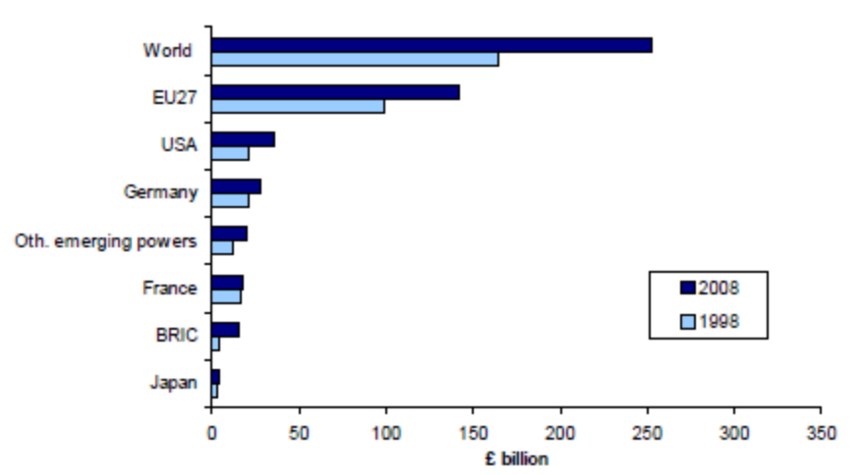
Data from: BIS, UK Trade Performance over the past years. Other emerging powers include: Indonesia, Malaysia, Mexico, Saudi Arabia, Singapore, South Africa, Thailand, United Arab Emirates, Bahrain, Iraq, Kuwait, Oman, Qatar, and Yemen.

London. London and its surrounding regions have grown, on average, over half a percentage point quicker than the rest of England since 1989 - a continuation of a forty year trend. As a consequence, workers and firms earn 46 per cent more in London and the surrounding regions than the rest of England.

Sectors. As in several other advanced (and some emerging) economies, there has been a shift away from manufacturing to (particularly knowledge-based) services. For example, the share in GDP of Business, Financial and Professional Services rose from 15 per cent in 1992 to 22 per cent in 2008, while the share of manufacturing fell from 21 per cent to 12 per cent (absolute manufacturing output actually rose but its share of the economy fell).

Consumption. About two thirds of the growth in demand over the past two decades was accounted for by consumption and UK consumption tends to also account for around two thirds of GDP. The contribution of Government to GDP also increased notably over this period. Business investment as a share of UK GDP rose over 1990 to 2008, but on average less than in our G7 peers.
- What happened to it?

Financial crisis. Given the increasing importance of financial and service industries, the UK economy was hit hard by the global banking crisis. This was especially negative for national GDP given the disproportionate contribution of London to national growth in the previous decades and the concentration of affected industries in the capital. UK GDP decline began in quarter two of 2008 and some growth resumed in quarter three of 2009. There was a ‘peak-to-trough’ fall of 7.1 per cent.

Debt. The effects of the global recession were worsened by high levels of government and personal debt. Our national debt had been driven up by years of Labour spending money that they didn’t have. The rapid withdrawal of credit facilities and the necessary emphasis put on paying off debt resulted in a contraction in consumption. Given the important contribution of consumption to growth over the last 20 years (with some of this consumption financed through debt), this drop-off in consumption was very negative for GDP.

Lower levels of investment. The combined effects of credit restriction (as documented in our earlier paper Credit after the Credit Crunch) and falling consumption led to fall off in investment – one of the direct inputs mentioned above.

Inflation. Elevated levels of inflation (combined with credit tightening) have been a drag on consumption over the past two years as inflation outpaced wage increases. But with the rate of inflation falling in December 2011, this trend could now be reversing.

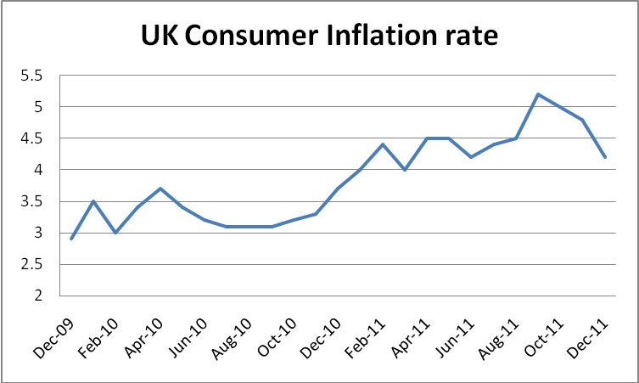
Data from: ONS, CPI reference tables

Eurozone crisis. Problems in the eurozone have been having a chilling effect on our economy for the past 18 months – leading as it did to a loss of confidence in our largest export market - and this will continue until eurozone leaders take concerted action to restore market confidence and stop unmanageable debt and deficits occurring all over again.

- The Coalition Approach – what we are doing now

Providing a firm foundation for sustainable growth. This Government’s decisive action to reduce the deficit is helping keeping interest rates low for taxpayers and homeowners and for businesses who want to invest. And reductions in business tax, reducing red tape and reform of the planning system is providing the right conditions for enterprise and innovation. Recent events in the Eurozone and elsewhere have underlined the importance of domestic policy that builds confidence and credibility. The UK has taken such action, and that is why it has low interest rates and strong credit rating, and why its deficit reduction plan has been endorsed by the IMF, OECD, European Commission, rating agencies and UK business organisations.

Dealing with Labour’s debt crisis. The June 2010 Budget set out plans to eliminate the bulk of the structural deficit within the Parliament. This means that debt will be on downward path by 2015.

Investing in the Regional Growth Fund. The Autumn Statement announced that we are boosting the Regional Growth Fund for England by £1 billion, with Barnet consequentials for the devolved administrations. The Regional Growth Fund has already allocated £1.4 billion to 169 projects supporting an estimated 325,000 jobs.

Corporation Tax cut. We reduced the main rate of corporation tax by 2 per cent in April 2011 to 26 per cent. In April 2012 it will fall to 25 per cent, and by 2014, it will be reduced to 23 per cent, the lowest in the G7.

Labour’s Jobs Tax stopped. The June 2010 Budget announced a reversal of the most damaging part of Labour’s planned increase in employer National Insurance Contributions (NICS) by raising the threshold by £21 a week above indexation in April 2011.

Introducing a £20 billion National Loan Guarantee Scheme to get cheaper loans to businesses. The Government will allow participating banks to raise up to a total of £20 billion of cheaper funding over the next two years under a government guarantee, provided they pass through this lower cost of funding to smaller businesses. In many cases, this will lead to a reduction of up to one percentage point on the cost of the business loan.

24 new Enterprise Zones. We have announced 24 new Enterprise Zones, including two in response to the recent announcement by BAE Systems of plans for potential job losses at their sites in Brough, Warton and Samlesbury, which will benefit from: up to 100 per cent business rate discount, simplified planning regulations, new superfast broadband, allowing business rates growth to be retained by the local authority and reinvested in the local area, and the potential to use enhanced capital allowances for zones with a strong focus on manufacturing.

Green Investment Bank. We have announced £2 billion pounds extra for the Green Investment Bank, giving it £3 billion of capital and enabling it to start operation in 2012 – a year early. Government investment alongside private finance should mean that there is £18 billion of investment in green infrastructure. The GIB will have borrowing powers from 2015-16.

Project Merlin – £190 billion of new business lending secured for 2011. In February 2011, as part of the Project Merlin agreements, the Chancellor announced that the banks intend to lend £190 billion of new credit to business in 2011, up from £179 billion in 2010. If demand exceeds this, banks will lend more. £76 billion of this lending will be to small and medium-sized enterprises (SMEs) – a 15 per cent increase on 2010 (£66 billion).

Simplification of the tax system. We have announced plans to consult on integrating the operation of income tax and national insurance contributions to remove distortions, reduce burdens on business and improve fairness. We also intend to scrap 43 tax reliefs which are no longer needed.

Doubling small business rate relief for two and a half years. Business rates can be a significant cost, particularly for smaller businesses. Originally we announced a doubling of small business rate relief for one year, this was extended at the 2011 Budget, and again at the Autumn Statement 2011 for a further six months from October 2012.

Introduction of fees for employment tribunals. From April 2013 the Government will introduce fees for employment tribunals. There is currently no charge for an applicant who wants to make an employment tribunal claim – unlike in the civil and family courts, where fees are routine. Fears of vexatious claims often act as a disincentive for businesses to employ new people. Introducing fees will help give businesses the confidence they need to create new jobs. We will consult on the level and structure for fees, and on ensuring remissions are available for the lowest paid.

Doubling the qualification period for unfair dismissal tribunals. We will double the qualification period for unfair dismissal tribunals. Currently an employee can claim for unfair dismissal after being employed for only a year. We will double that, so from April 2012 employees will only be able to make a claim after two years. ‘Day one’ rights – such as the right not to be discriminated against – will not be affected.

Cutting red tape. We are scrapping new regulations that would have cost businesses over £350 million per year; and radically reforming the planning system by introducing a new default presumption in favour of sustainable development and streamlining over 1,000 pages of planning policy to just 52 pages.

Streamlining the planning process. We will streamline the planning system by removing bureaucracy and speeding up the process. This will include a 12 month guarantee for the processing of all planning applications, including any appeals.

Reform of Enterprise Investment Scheme. To encourage investment in businesses with high growth potential, we will raise the rate of Enterprise Investment Scheme income tax relief to 30 per cent from April 2011. And next year we will double the amount that any individual can invest through the EIS, increase the size of company that can qualify for investment – and raise the limit on the amount that can be invested in a company by 400 per cent.

Apprenticeships and Work Experience. We will fund an additional 80,000 work experience places for young people – ensuring 100,000 places will be available over the next two years. We will give £180 million to provide up to 50,000 additional apprenticeship places over the next four years. This means we will fund at least 250,000 more apprenticeships than Labour planned.

Exempting start-ups from new regulation. At the March Budget, we announced an unprecedented moratorium exempting micro and start-up business from new domestic regulation for three years.

Launching a new Seed Enterprise Investment Scheme (SEIS). To encourage investment in new start-up companies we are launching a new Seed Enterprise Investment Scheme (SEIS) from April 2012, offering 50 per cent income tax relief on investment, and a capital gains tax exemption on gains realised in 2012-13 and then invested through SEIS.

Enterprise Finance Guarantee increased. To enable lending to viable small businesses that lack collateral or a track record, the Enterprise Finance Guarantee scheme will provide up to £600 million of additional lending to around 6,000 businesses in 2012 and, subject to demand, over £2 billion in total.

Extending Entrepreneurs Relief. We have raised the lifetime limit on capital gains qualifying for Entrepreneurs’ Relief to £10 million. This will help to make the UK a more attractive location for entrepreneurs by encouraging serial entrepreneurs who want to expand their business and reinvest growth.

Ending the compensation culture. We will extend the current scheme that caps the amount that lawyers can earn from small value personal injury claims, and reduce overall costs in cases funded by ‘no win no fee’ deals. We will also change the health and safety law on strict liability for civil claims so that businesses are no longer automatically at fault if something goes wrong.

Major trade visits. The Prime Minister has led trade visits to India, China, Russia, sub-Saharan Africa and the Gulf.

Innovation and Research. The Coalition published its Innovation and Research Strategy for Growth on 8 December 2011. The strategy centres on supporting business R&D in areas in which the UK excels, within the context of developing the wider UK innovation eco-system including universities and other organisations. The Government is maintaining the annual £4.6 billion budget for science and research programmes with £150 million each year supporting university-business interaction, and has committed an additional £495 million to Science Capital Investment projects since January 2011.

SME research. In addition to changes to the SME R&D Tax Credit the Coalition will invest an additional £75 million to support small business innovation including additional funding for Smart (grants that support SME research and development) and implement a new innovation voucher programme enabling small businesses to engage with universities and the wider knowledge base. We will invest more in the Small Business Research Initiative helping more small businesses to win government contracts for their innovative products and services.

- Questions for discussion - what comes after 2015?

- What should be the role of the Government in encouraging growth?

- Where in the World will growth come from? Who will we be exporting to and importing from?

- How can we encourage more people back into the workplace? What can the government do to incentivise flexible or part-time working?

- In your area, what is the most important industry or market? If government could do one thing to help increase growth or improve productivity in that market, what would it be?

- Are there skills or resources in your area which could benefit from special support? What are they, and what support would help?

- What would economic success look like in your area? Is GDP a relevant measure?

Resources

www.conservativepolicyforum.com
As always, this month we will be hosting a series of blog posts related to our Discussion Brief. Our website is also home to best practice examples from CPF Groups across the country, news on CPF events and a series of online surveys – why not distribute links to these surveys to your friends and local associations to interest more CPF members?

The Telegraph, 2012, George Osborne: There is a golden opportunity to be seized in Asia
http://www.telegraph.co.uk/finance/economics/9016975/There-is-a-golden-opportunity-to-be-seized-in-Asia.html

VIDEO: BBC News, 2012, David Cameron: Growth to come from start-ups
http://www.bbc.co.uk/news/uk-politics-16459492

The Guardian, 2012, UK export and import in 2011: top products and trading partners
http://www.guardian.co.uk/news/datablog/2010/feb/24/uk-trade-exports-imports

The Financial Times, 2011, Dad, Where does growth come from?
http://ftalphaville.ft.com/blog/2011/10/24/710186/dad-where-does-growth-come-from/

BIS, 2011, Sources of Economic Growth, Trade and Investment http://www.bis.gov.uk/assets/biscore/international-trade-investment-and-development/docs/s/11-723-sources-of-economic-growth

Endnotes

BIS, 2011, Sources of Economic Growth, Trade and Investment Analytical Papers Topic 6 of 18, p.6 [Accessed 11 January 2012]: http://www.bis.gov.uk/assets/biscore/international-trade-investment-and-development/docs/s/11-723-sources-of-economic-growth
BIS, 2010, UK trade performance: Patterns in UK and global trade growth, BIS Economics Paper no. 8, p.50 [Accessed 11 January 2012]: http://www.bis.gov.uk/assets/biscore/economics-and-statistics/docs/u/10-803-uk-trade-performance-growth-patterns
BIS, 2011, UK Trade Performance over the past years, Trade and Investment Analytical Papers Topic 3 of 18, p.9 [Accessed 11 January 2012]: http://www.bis.gov.uk/assets/biscore/international-trade-investment-and-development/docs/u/11-720-uk-trade-performance
BIS, 2011, UK Trade Performance over the past years, Trade and Investment Analytical Papers Topic 3 of 18, p.9 [Accessed 11 January 2012]: http://www.bis.gov.uk/assets/biscore/international-trade-investment-and-development/docs/u/11-720-uk-trade-performance
BIS, 2010, Economic Growth, BIS Economics Paper no. 9, p.10 [Accessed 11 January 2012]: http://www.bis.gov.uk/assets/biscore/economics-and-statistics/docs/e/10-1213-economic-growth.pdf
BIS, 2011, Sources of Economic Growth, Trade and Investment Analytical Papers Topic 6 of 18, p.7 [Accessed 11 January 2012]: http://www.bis.gov.uk/assets/biscore/international-trade-investment-and-development/docs/s/11-723-sources-of-economic-growth
BIS, 2011, Sources of Economic Growth, Trade and Investment Analytical Papers Topic 6 of 18, p.6 [Accessed 11 January 2012]: http://www.bis.gov.uk/assets/biscore/international-trade-investment-and-development/docs/s/11-723-sources-of-economic-growth
Independent Commission on Banking, 2011, Interim Report: Consultation on Reform Options, p.5 [Accessed 19 January 2012]: http://www.hm-treasury.gov.uk/d/icb_interim_report_full_document.pdf
ONS, 2011, Quarterly National Accounts - Q2 2011, p.9 [Accessed 26 January 2012]: http://www.ons.gov.uk/ons/rel/naa2/quarterly-national-accounts/q2-2011/sbd-quarterly-national-accounts-q2-2011.pdf
BBC News, 2012, UK inflation rate falls to 4.2% in December [Accessed 19 January 2012]: http://www.bbc.co.uk/news/business-16591740
ONS, 2011, Detailed CPI and RPI Reference Tables [Accessed 2 February 2012]: http://www.ons.gov.uk/ons/publications/re-reference-tables.html?edition=tcm%3A77-223935

